**Week 8 Module 11.2 Assignment**

Juan Macias Vasquez

Bellevue University

CSD340-H323 Web Development with HTML and CSS (2261-DD)

**Adam Bailey**

October 5th, 2025

**Module 11.2**

**JavaScript Exercise, Part 3**

**GitHub Repository Link**

<https://github.com/Juan551School/csd-340>

**Link to GitHub pages landing page**

<https://juan551school.github.io/csd-340/>

**Project 11.2 Page**

<https://juan551school.github.io/csd-340/module-11\assignment-11.2\Macias_Mod11_2.html>

**HTML Code Macias_Mod11_2.html**

<!-- Juan Carlos Macias Vasquez

Week 8 Module 11.2 Assignment

CSD340-H323 Web Development with HTML and CSS(2261-DD)

October 5th, 2025

JavaScript Exercise, Part 3

Html file

-->

<!DOCTYPE html>

<html lang="en">

<head>

<meta charset="UTF-8">

<title>CSD 340 Web Development with HTML and CSS</title>

</head>

<body>

<h1>Assignment 11.2: JavaScript - Part 3</h1>

<p>

This is an interactive To Do List. Type in your first item in the text box, then click Add.

Click the Display button to see current items in the list.

Click on Delete Last Entry if you'd like to remove the last entry.

</p>

<!-- Text box and the buttons -->

<input type="text" id="todoInput" placeholder="Enter a task">

<button onclick="addItem()">Add</button>

<button onclick="deleteLastItem()">Delete Last Entry</button>

<button onclick="displayItems()">Display</button>

<hr>

<!-- Where the list will be shown -->

<div id="todoList"></div>

<!-- Not 100% sure if this is good havent really used JavaScript but it worked-->

<script>

// Array to hold To Do List items

let todoArray = [];

// Function to add an item

function addItem() {

let item = document.getElementById("todoInput").value;

if (item === "") {

alert("Please enter something before adding!");

return;

}

todoArray.push(item);

alert("Item: " + item + " Added as Item " + todoArray.length);

document.getElementById("todoInput").value = ""; // clear box

}

// Function to delete the last item

function deleteLastItem() {

if (todoArray.length === 0) {

alert("No items to delete.");

return;

}

let removed = todoArray.pop();

alert("Removed last item: " + removed);

}

// Function to display items

function displayItems() {

let output = "";

for (let i = 0; i < todoArray.length; i++) {

output += "Item " + (i + 1) + " = " + todoArray[i] + "<br>";

}

document.getElementById("todoList").innerHTML = output;

}

</script>

<!-- Footer -->

<footer>

<p>&copy; 2025 Your Name - CSD 340 Web Development with HTML and CSS</p>

<p><a href="../../index.html">back to Landing Page</a></p>

</footer>

</body>

</html>

**Pictures of webpage**

**When you first start**

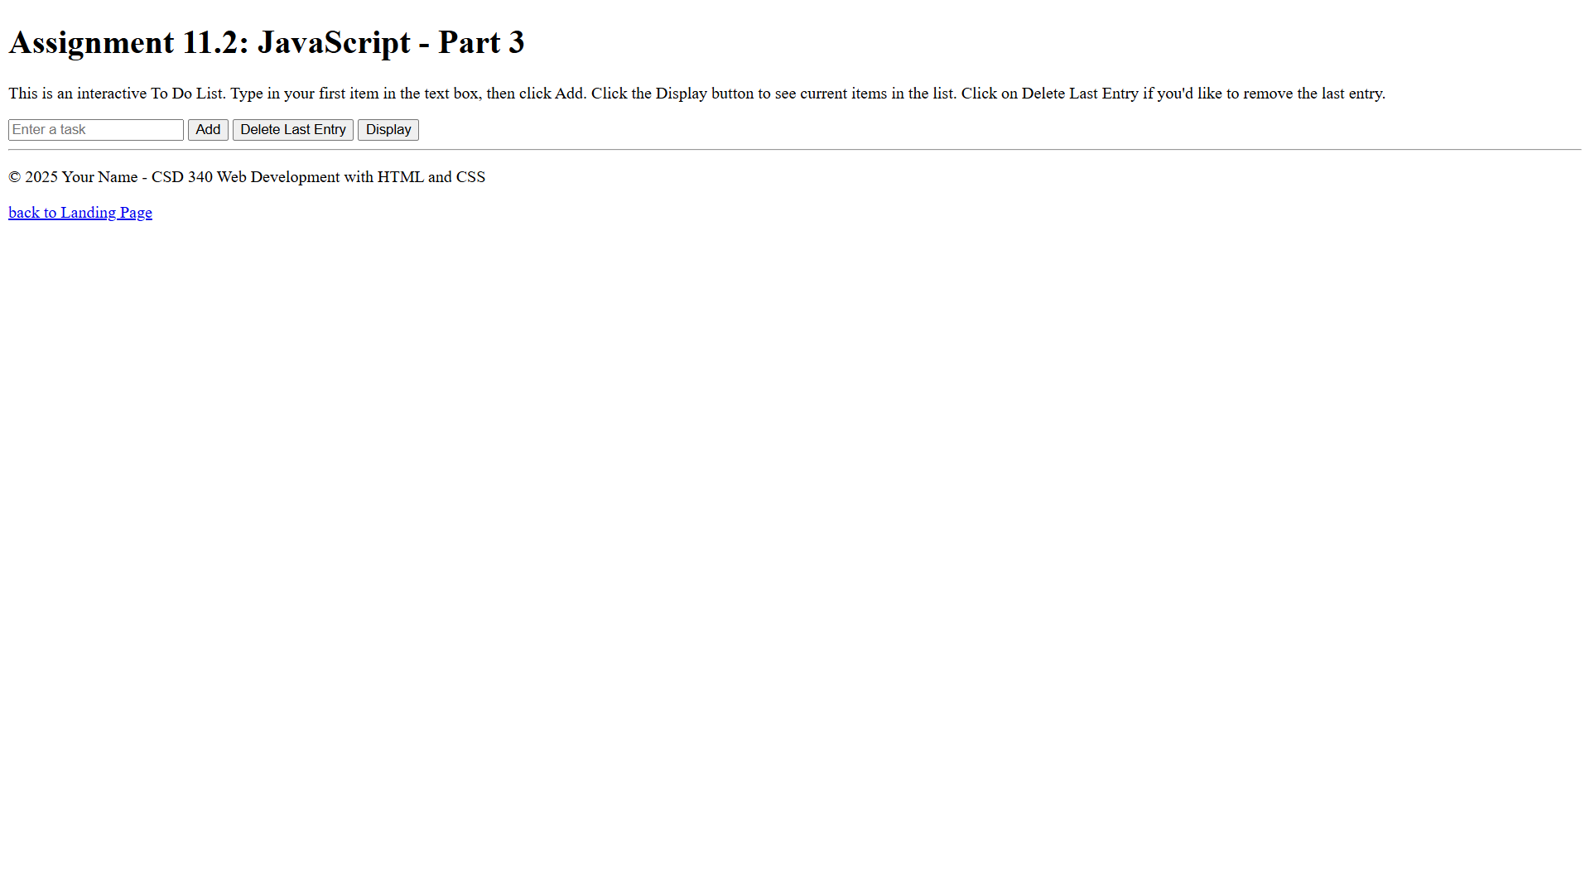

**Adding some items**

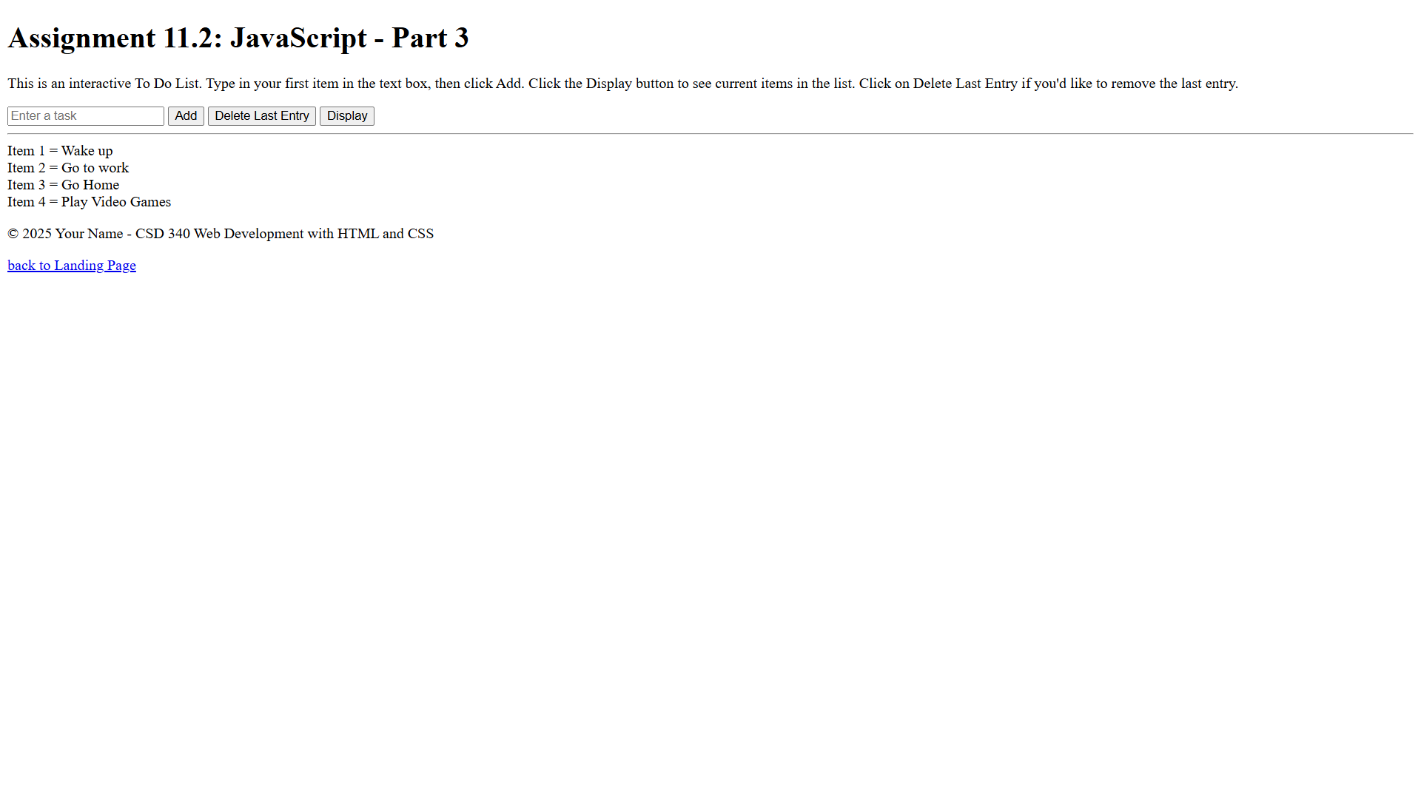

**Deleting last item and adding another**

